iPAD: ACCESSIBILITY FEATURES AND APPS FOR ACCESS TO CURRICULUM
These are the features and apps I use with students to help with work completion.
- Speech-to-Text: if the Enable Dictation feature in the student’s iPad is activated, the student can dictate into any app that accepts typing. Need to be connected to Wi-Fi for this to work in any language other than English. Settings -> General -> Keyboards -> Enable Dictation. The microphone will show up on the bottom of the screen if using an external keyboard.
- 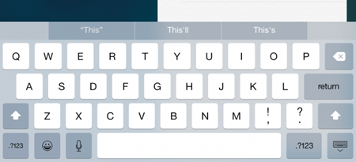

- Word prediction: on the onscreen keyboard will display word prediction above the keyboard if this feature is enabled in settings. Settings -> General -> Keyboards -> Predictive. Can be helpful for weak spellers or poor typists with some reading skills. Will also show up on the bottom of the screen if using an external keyboard instead of the onscreen keyboard.

  - Enable Hold to Speak Predictions so you can hear each word in the prediction display be read aloud Settings -> Accessibility -> Spoken Content -> Typing Feedback -> Hold to Speak Predictions. Helps students who are weak readers. Press on the word and swipe (don’t lift) your finger away after the word is spoken. If you lift your finger off, it will insert the word. It can be a difficult gesture to master for some students and takes practice!

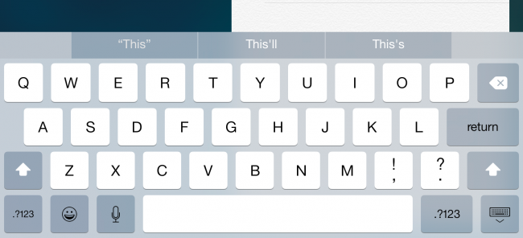

- Text-to-Speech: can be used if the Speak Selection setting is enabled in the Accessibility section of the settings. Settings -> Accessibility -> Spoken Content -> Speak Selection. In Spoken Content you can also set the rate of speech, a different voice, and how you want to highlight words and/or sentences as they are spoken. This feature only works with accessible text, such as content in Docs, Forms, websites that are accessible, Slides if the text is typed into the slide and not an image copied and pasted into the Slide.

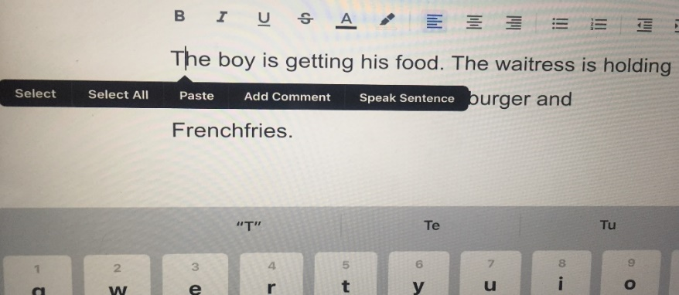

  - After you press (not a tap) on the text to be read, the black menu appears. You can Select (individual sentence or specific sentences), Select All (everything in the document), or Speak Sentence (place the cursor on the sentence you want to hear) to hear text spoken aloud. Select will ask you specify what text is to be read by dragging your finger across the text to highlight it. Speak Sentence will read only the sentence the cursor is on.

- Annotation on a document: In the Photo app, there is the Markup feature that allows you to take a photo of a document, and write, type, or dictate onto the photo.
  - Take a photo of the document
  - Tap Edit in top right corner
  - Photo opens, you can adjust it if it is crooked, or if you want to change the margins to only surround the document and show no other background. Once adjusted hit Done.
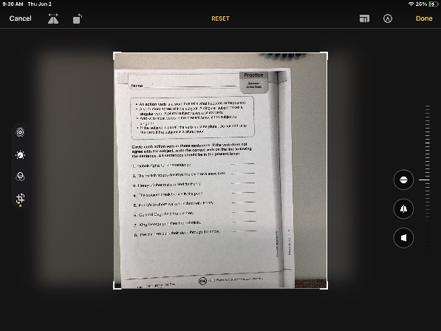
  - Tap on Edit
  - Tap on the pen icon (pen with circle around it) in top right-hand corner
  - A menu of writing tools opens, and you have the option to handwrite or color with two different styles of pen, highlight, erase, delete something you have inserted like an image, or use a ruler to measure. You have options for colors and thickness of stroke.
  - To type or dictate onto the document you need a text box. Tap on the + to receive the pop-up menu and tap on Text.
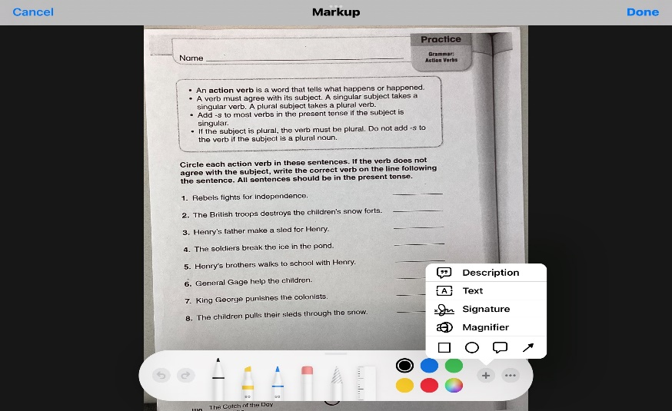

  - A text box opens in the middle of the document; press on the text box and get the black menu, tap on Edit
  - Move text box to the appropriate area on the document.
  - Use keyboard to type or dictate responses into text box.
    - iOS spell check works in the text box
    - The text box becomes longer as you enter text, you can also lengthen it by dragging one of the sides left or right
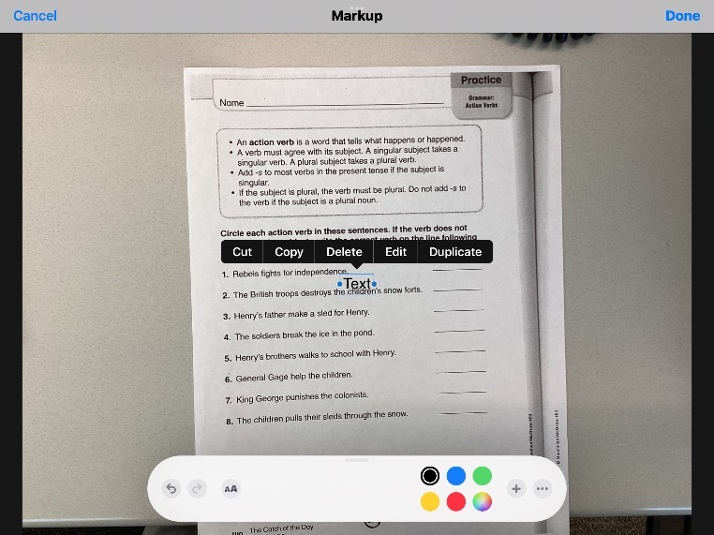

- When done marking responses, tap on Done in top right corner. You can now email, share, or AirDrop (if teacher is using an iPad) the document to teacher. Stays in Photo app until deleted. Can go back and work on it again if needed.

- Live Text Recognition: Using the camera, you can take a photo of typed text, and can use the Speak Selection feature to read the text aloud. You can also copy and paste the text into another document (notes, Docs) to read later using Speak Selection. *Live Text is available on iPad Pro 12.9-inch (3rd generation) or later, iPad Pro 11-inch (all models), iPad Air (3rd generation) or later, iPad (8th generation) or later, and iPad mini (5th generation) or later with iPad OS 15.1 or later.
  - Open the camera and aim at the text you want to read
  - When the camera recognizes text, a white symbol opens at the top of the symbols on the right side of the screen and yellow corners appear around the text on the screen
  - Instead of snapping the photo with the white button, snap the photo with the new white symbol
  - The screen changes and the black menu appears.
    - Tap where you want it to start reading, the menu may move, and the blue select overlay appears on the text.
    - You can select specific text by adjusting the blue overlay, or hit Select All in the black menu. You can read this live text by tapping on Speak. If you close this photo, it does not save in Photo Roll in this format.
    - You can also tap on Select All and Copy. This would allow you to paste this text into a Doc or Note to read at a later time using Speak Selection.

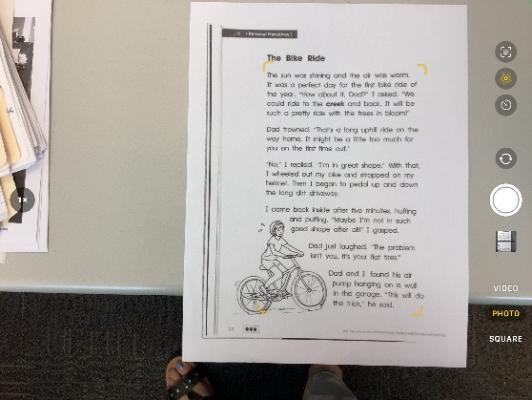
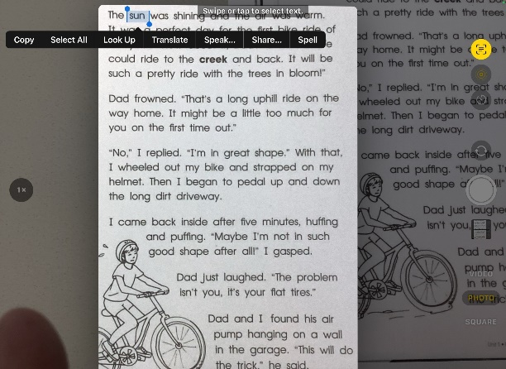

Looks like this but white

- Scanning: There is a scanning option in the Notes app which will allow you to scan a document and open it in another app to use. Once you have that scanned document (it is now a PDF and looks like a document rather than a photo), you can upload it into another app so that you can annotate responses on the document, email it to someone, or store it in Google Drive to share with others or use with another device. You can scan worksheets, workbook pages, math sheets, graphic organizers, or anything that is in paper format and/or you want to maintain the formatting. *Apps that I typically recommend that use PDFs or scanned documents typically have their own scanning feature so there may not be a need to use this feature very often.
  - Scan a document:
    - Open Notes app: this app comes with every iPad or iPhone
    - Open a new note by tapping on the square with a pencil sticking out of it; it may be at the top right corner on the iPad or the bottom right corner of the iPhone
    - Tap on the camera icon: on iPad this may be in the top right corner. On iPhone it is on the keyboard
    - Tap on Scan Document
    - Position the document in the camera view and once it is good, the camera will snap the photo automatically
    - Adjust the corners of the document if needed to capture the entire document
    - Tap on Keep Scan
    - If there is more than one page to scan, for example, a packet of pages, you would take a picture of each page. To scan a packet successfully, the pages should all be oriented in the same direction. If one page is in landscape and others are in portrait orientation, then it will be hard to work with them when they are uploaded as one document into another app.
    - When done scanning, tap on Save. This document is now in PDF format. It will remain in Notes until you delete it.

  - Send the PDF document to another app so that you can do something with it:
    - Tap on the three dots in the upper right corner, tap on send a copy
    - Find the app icon you want to use with this PDF and tap on it; the PDF will upload into that app. You can email it, message it, or upload it into another app for use.

- Keyboards in different languages: In keyboard settings, you can add keyboards of many different languages. When a keyboard in another language is displayed on the screen, you also have word prediction in that language, can use use Dictation in that language, and Speak Selection will read in that language. General -> Keyboard -> Keyboards -> Add a New Keyboard. Pick the language you want to add. There is a Spanish (Mexico) keyboard. Once you have added the keyboard, you can easily switch between the keyboards by tapping on the keyboard settings button (bottom left) on the onscreen keyboard. You can easily insert accents on letters by pressing on the letter key and sliding your finger up to the desired accent on the menu that appears. Once you lift your finger it will insert.
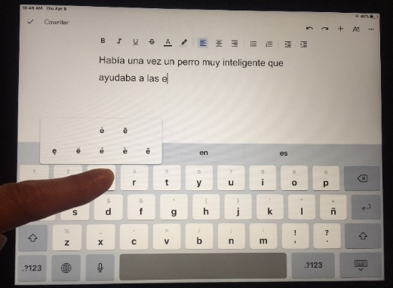

There are also many features in the accessibility and spoken content sections of General Settings that can personalize the appearance or activate certain features that make using the iPad easier depending on the student’s specific needs. Changes to size and boldness of characters or icons, changing or inverting colors, typing feedback, speech feedback, etc.
Free AT APPS that I often recommend:
- Notability: Scan a paper document directly within the app or upload from email, Google Drive, Google Classroom, or Canvas. Great tool for students who have terrible handwriting. Can be challenging to operate when using onscreen keyboard for typing or dictation as the keyboard covers most of the document. Can also create documents in Notability using graph paper or lined paper.
- Dolphin Easy Reader: free app for accessing digital books. Can search directly for Bookshare books and other libraries.
Other Apps I often recommend but cost money:
- iWordQ: Word prediction apps such as iWordQ are more powerful and intuitive than the predicative text that appears on the onscreen keyboard. If the student is really a phonetic speller, has language difficulties, and spell check or predicative text on the keyboard aren’t supportive enough, then I may suggest a word prediction app. There are different word prediction apps and they have different features, so depending on the needs of the student I may recommend one over the other. iWordQ is easy to operate and very supportive. You must copy and paste the text created in these apps into a word processing document to share it with a teacher in document format, otherwise the text shows up in the email to the teacher.

- ClaroPDF Pro: this great app does it all! You can scan a document within the app and convert it with OCR so that the text can be read aloud with highlighting. You can listen to the text and then annotate a response either by typing or dictating. Works in many languages. A little complicated but with practice and good support, students can learn to use it successfully.

- Voice Dream Reader (VDR): a great text reader app. It can scan documents with OCR right in the app to make it readable text. Can search directly for Bookshare books through the app.

Kelly Cox/ATAC kcox@vcoe.org Apps and features may change with iOS updates and districts may set up their iPads differently than mine so some features may not work or work in the same way updated 6/2022

