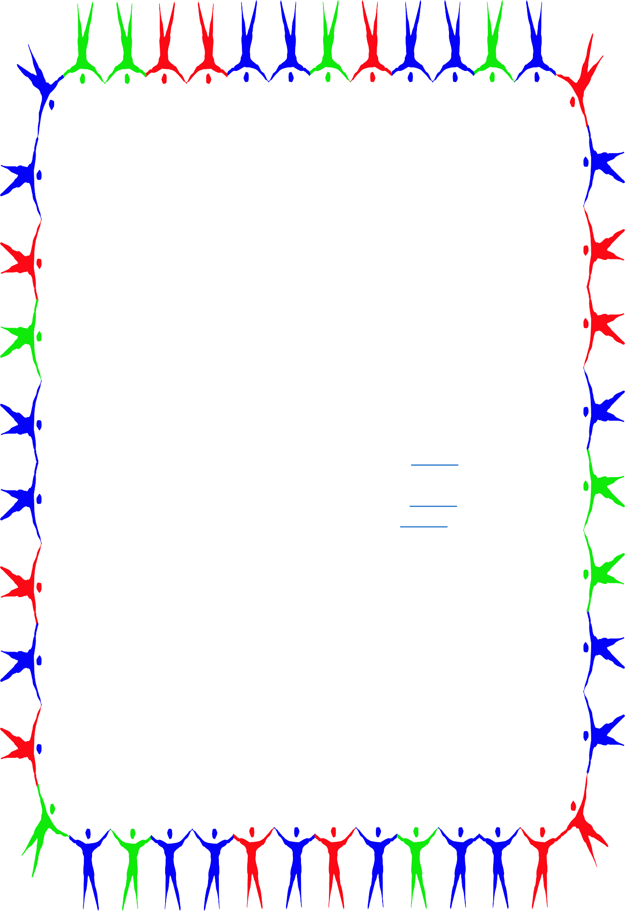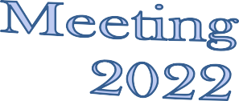

Ventura County Transition Project

October 20, 2022 2:00p.m.-3:30p.m.
TCRC Employment Collaborative

October 20, 2022, 3:30 – 4:30 p.m. Virtual
December 7, 2022, 3:00 – 4:30 p.m. Hybrid (Santa Paula Room)
February 9, 2023, 3:00 – 4:30 p.m. Virtual
April 27, 2023, *3:00- 4:30 p.m. Virtual

Transition Fair Agency Padlet Transition Fair Flyer

Transition Fairs: Wednesday, November 9, 2022;
5:30pm-8:00pm Virtual and
Saturday, February 25, 2023: 9:00am-12:00pm In Person

Parents welcome to all meetings and events.
Contact SELPA for more information
(805) 437-1560

